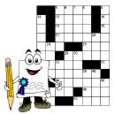

Crossword Puzzle

You are to make a crossword puzzle about your state. You must use at least 20 words about your state. The following website will help you: http://www.puzzle-maker.com/CW/

